Deliverables:

Software Requirements:

1. A **Linux-Based Operating System** to deploy and operate facial and fingerprint recognition algorithms.
2. A **User-Interface Application** allow user to interact with the smart lock using devices.

Hardware Requirements:

1. A **Camera** to capture facial images of users and used in identifying faces.
2. **Fingerprint Scanner** to recognize and authenticate user’s fingerprint.
3. A **Raspberry Pi** as the microcontroller to capture data and communicate with devices.
4. **Display Screen** to navigating user and displaying messages.

Intelligence System Architectures:

One potential neural network architecture for a smart lock with facial and fingerprint recognition is a convolutional neural network (CNN). CNNs are well-suited for image-based tasks such as facial recognition because they can extract useful features from the raw data and classify them based on patterns and structures present in the images.

Outcomes of the System:

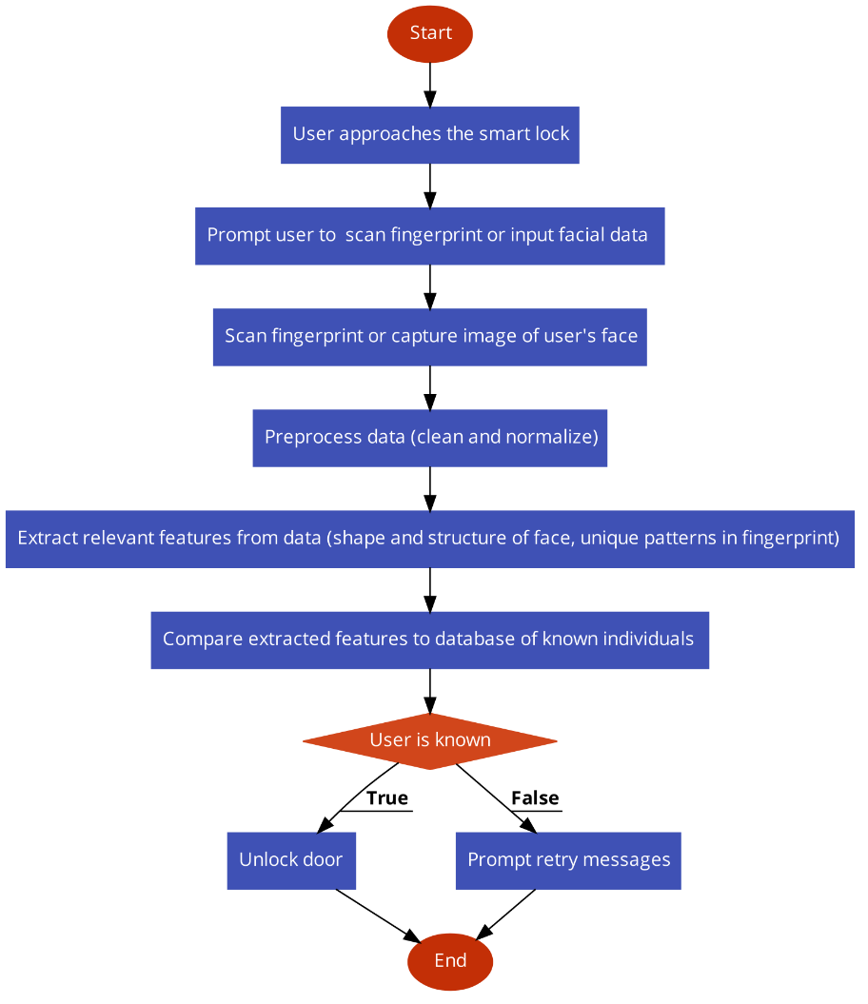

Tasks and Estimated Costs:

|  |  |  |
| --- | --- | --- |
| Task | Cost | Note |
| Procurement of hardware and software components | $ 1000 | The cost of hardware and software components will depend on the specific components needed for the smart lock system, as well as the quantity and quality of the components. |
| Integration of hardware and software components | $ 800 | Integration of hardware and software components will involve connecting and configuring the various components of the system, such as the camera, fingerprint scanner, microprocessor, and display. |
| Testing and debugging of system | $ 450 | Testing and debugging of the system will involve running a series of tests to ensure that the system is functioning correctly and efficiently. |
| Deployment and installation of system | $ 700 | Deployment and installation of the system will involve installing the system in the desired location and configuring it to work with any connected devices or systems. |
| Training and support for users | $ 500 | Training and support for users will involve providing users with the necessary knowledge and skills to use the system effectively. |

Milestone Chart

